
School: ............................................................................................................. Campus: ....................................................... Academic Year: ...................... Subject Name: ........................................................... Subject Code: ..........................
Semester: ............... Program: ........................................ Branch: ......................... Specialization: .......................... Date: .....................................
(Learning by Doing and Discovery)
* Coding Phase: Pseudo Code / Flow Chart / Algorithm
NFT Creation and Deployment
Step 1: Prepare NFT Metadata
- Open VS Code (Visual Studio Code).
- Create a JSON file named nft_metadata.json with your NFT metadata:
{
"name": "CUTM Badge #2",
"description": "NFT demo for Blockchain Studnets on Sepolia.",
"image": "https://brown-important-alpaca-785.mypinata.cloud/ipfs/bafkreih42pxk2yk6jzxi24nzhn34ycfxislehun6mgkws4ulsn3vgh5mb4",
"attributes": [
{
"trait_type": "Department",
"value": "CSE"
},
{
"trait_type": "Campus",
"value": "BBSR"
}
]
}
Step 2: Upload NFT Image to IPFS via Pinata
- Go to Pinata and log in.
- Navigate to the API Keys section and generate a new key with appropriate access.
- Upload your NFT image (e.g., ganesha.png) to IPFS using the Pinata upload tool.
- Copy the CID or the IPFS URL of the uploaded image.
- Paste the IPFS image link (e.g., ipfs://<CID>/ganesha.png) into the image field of your nft_metadata.json.
Step 3: Upload Metadata JSON to IPFS
- After updating your metadata file with the correct image IPFS link, upload nft_metadata.json to Pinata.
- Copy the CID or IPFS URL of this metadata file.
Example: ipfs://<CID>/nft_metadata.json
Step 4: Write the Smart Contract in Solidity
- Open Remix IDE.
- Create a new file named NFT.sol.
- Paste the following contract code:
// SPDX-License-Identifier: MIT
pragma solidity ^0.8.24;

import "@openzeppelin/contracts/token/ERC721/extensions/ERC721URIStorage.sol";
import "@openzeppelin/contracts/access/Ownable.sol";

contract Ganesha is ERC721URIStorage, Ownable {
uint256 private _nextId;

constructor(string memory name_, string memory symbol_, address initialOwner)
ERC721(name_, symbol_)
Ownable(initialOwner)
{}

function mintTo(address to, string memory metadataURI) external onlyOwner returns (uint256) {
_nextId += 1;
uint256 tokenId = _nextId;
_safeMint(to, tokenId);
_setTokenURI(tokenId, metadataURI);
return tokenId;
}

function totalMinted() external view returns (uint256) {
return _nextId;
}
}

Coding Phase: Pseudo Code / Flow Chart / Algorithm
Step 5: Compile the Contract
- In Remix, navigate to the Solidity Compiler tab.
- Select the appropriate compiler version (^0.8.24).
- Click Compile NFT.sol.

Step 6: Deploy the Contract
- Go to the Deploy & Run Transactions tab.
- Select the Injected Provider - MetaMask environment to connect your wallet.
- Provide the constructor parameters:
  - name_: e.g., Ganesha
  - symbol_: e.g., GNSH
  - initialOwner: Your MetaMask address
- Click Deploy and approve the transaction in MetaMask
.
Step 7: Mint the NFT
- After deployment, use the contract’s mintTo function:
  - to: Your MetaMask address
  - metadataURI: The IPFS URL of your nft_metadata.json file (e.g., ipfs://<CID>/nft_metadata.json)
- Click Transact and approve the minting transaction.

Step 8: View Your NFT
- Once the NFT is minted, it should be visible in your MetaMask wallet under NFTs (if supported).

* Softwares used
Pinata
Remix IDE
VScode

- Testing Phase: Compilation of Code (error detection)
No Error

- Implementation Phase: Final Output (no error)
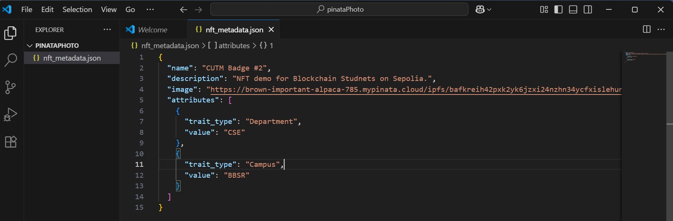

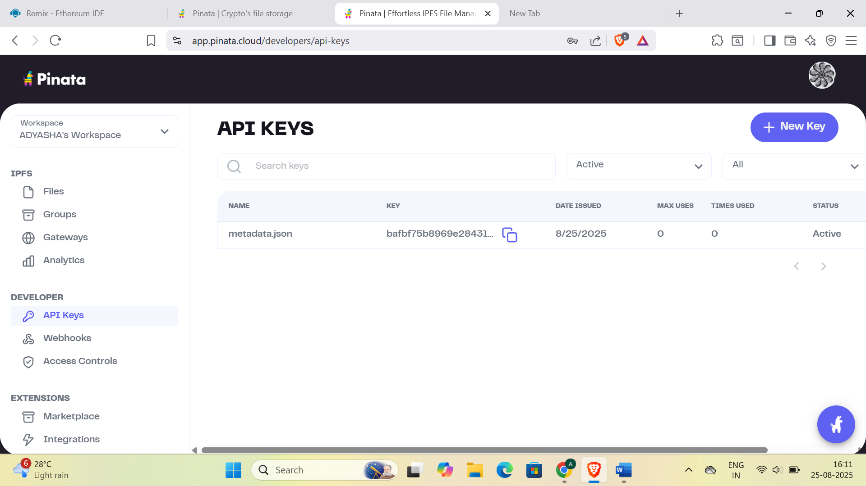
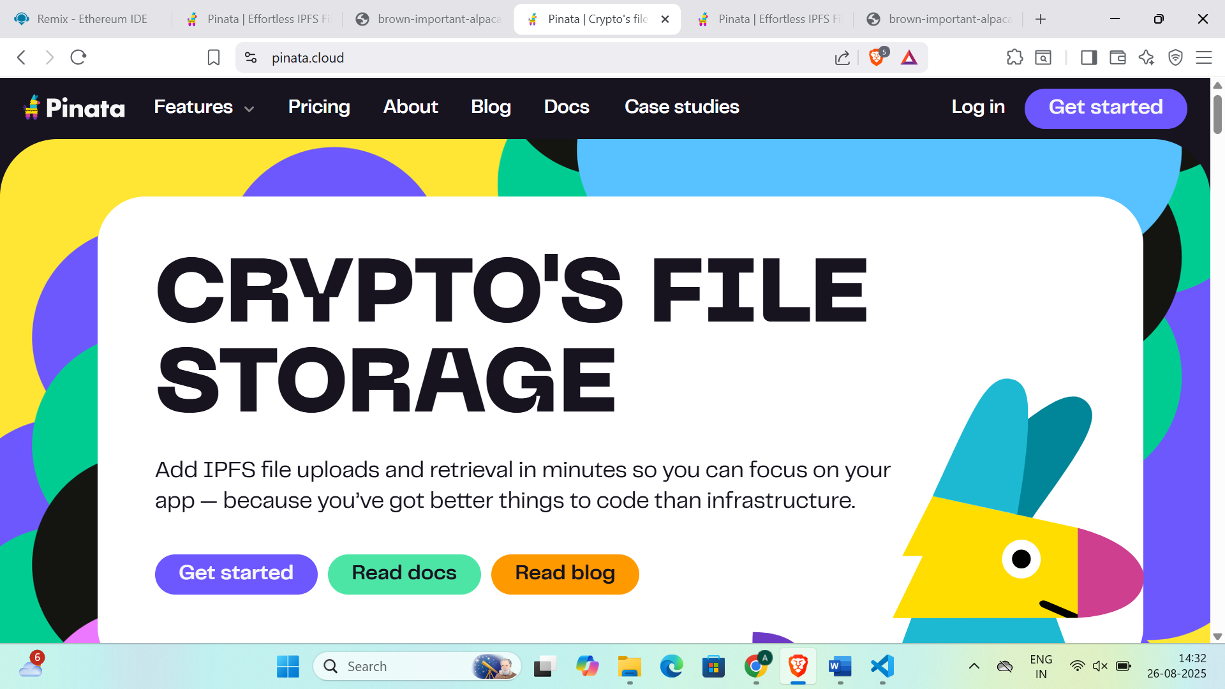

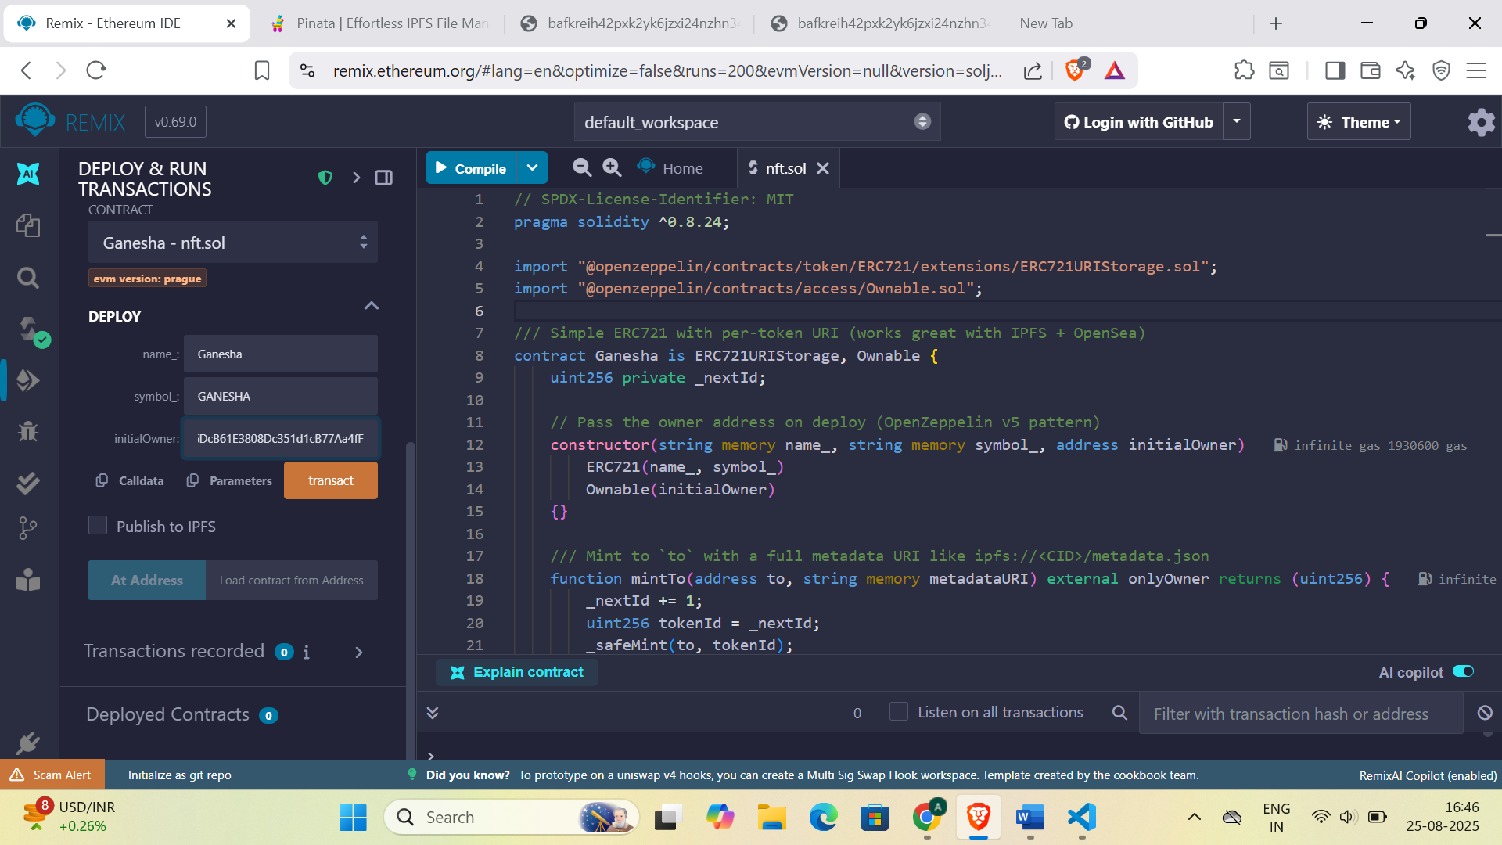

Implementation Phase: Final Output (no error)
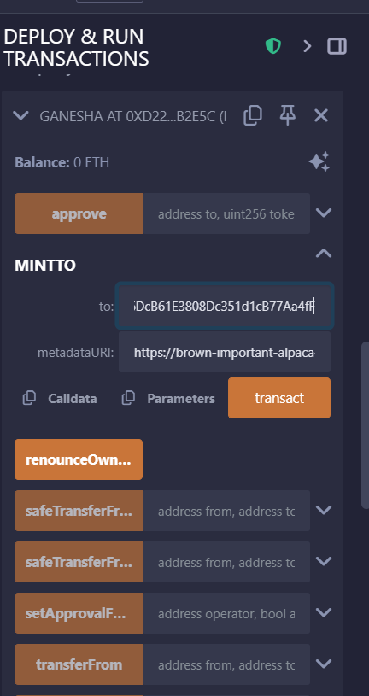
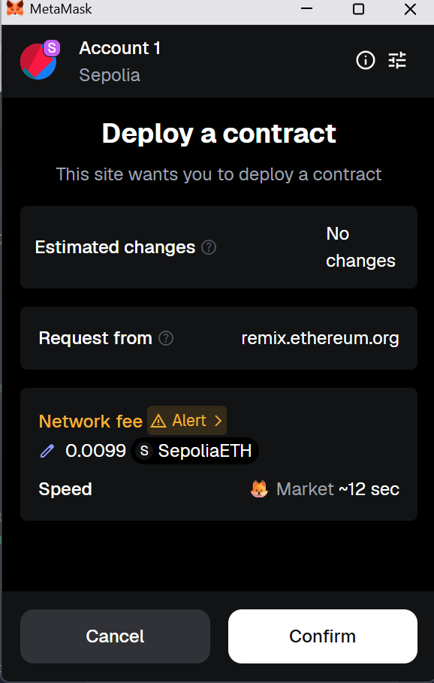

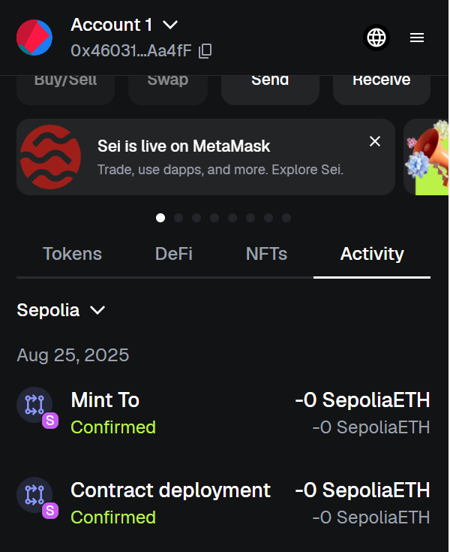
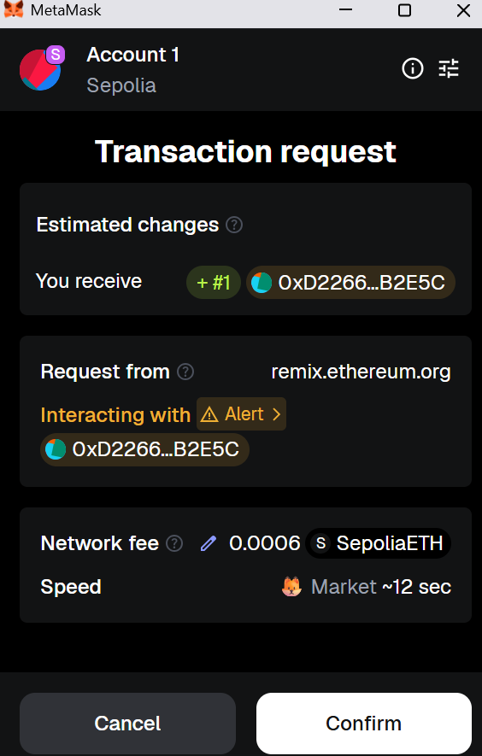

- Implementation Phase: Final Output (no error)
Applied and Action Learning

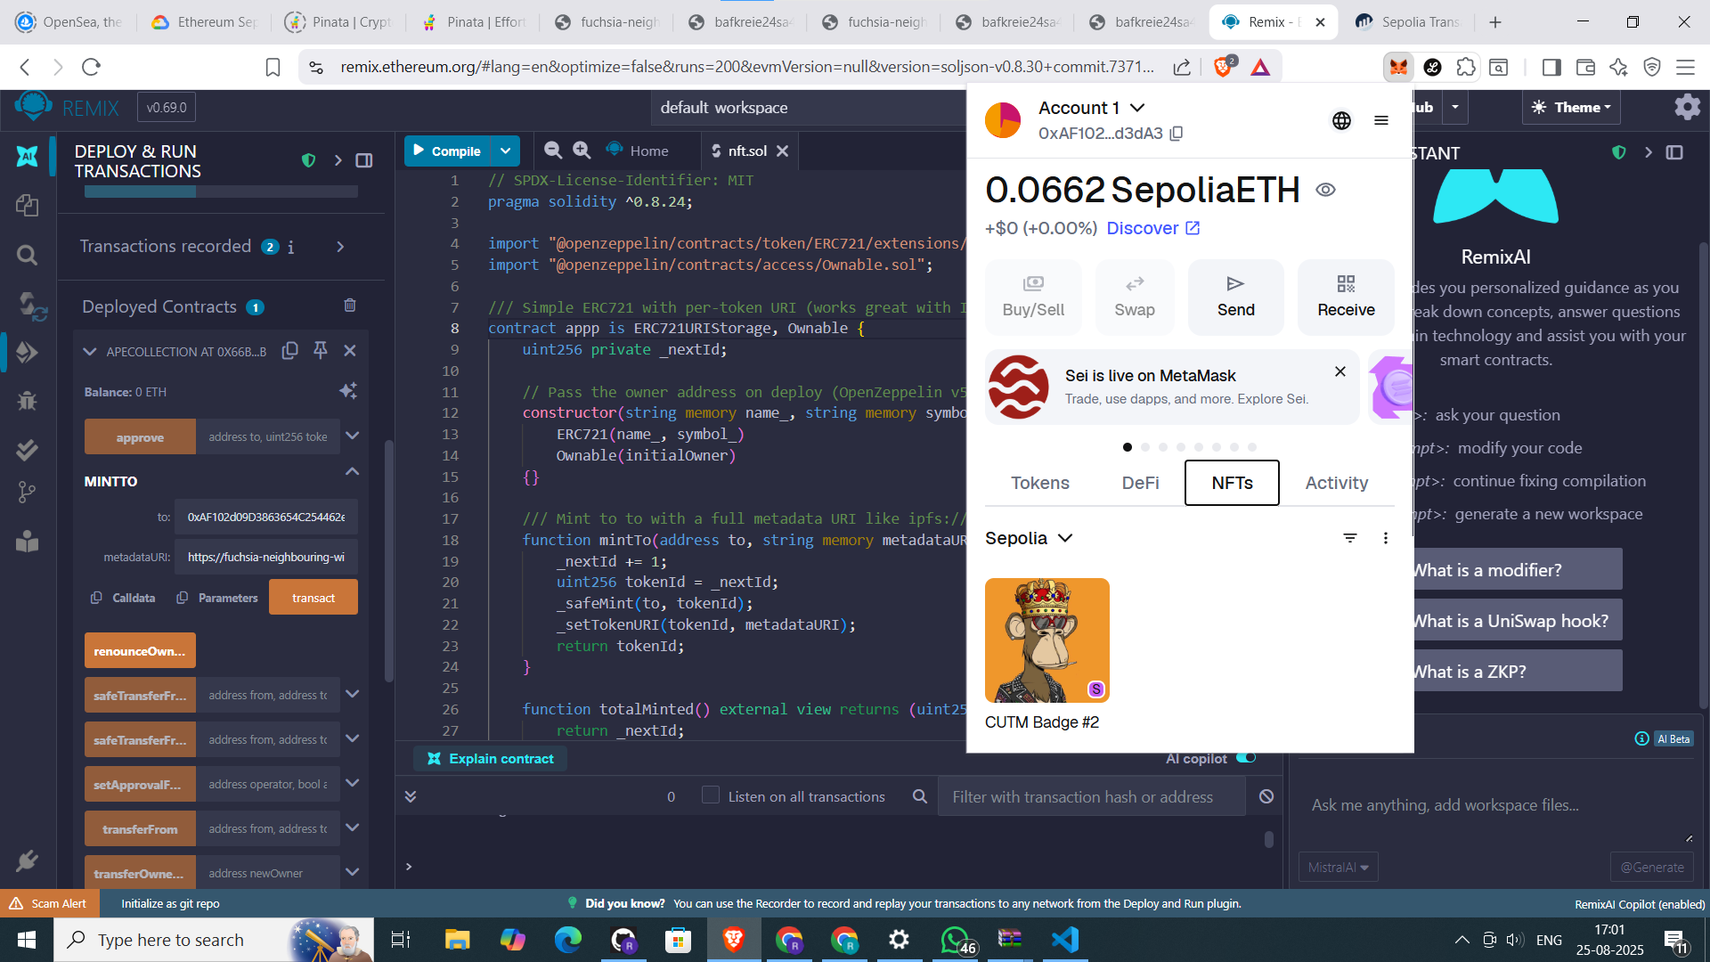

* Observations
- Metadata was properly structured and uploaded to IPFS using Pinata.
- Smart contract used OpenZeppelin’s ERC721URIStorage for NFT functionality.
- Image and metadata were stored on IPFS, ensuring decentralization.
- Contract deployed successfully using Remix and MetaMask.
- NFT was minted correctly and appeared in the MetaMask wallet.
- The process followed best practices for secure and efficient NFT deployment.

ASSESMENT

Rubrics
Concept | 10
Planning and Execution/  Practical Simulation/ Programming | 10
Result and Interpretation | 10
Record of Applied and Action Learning | 10
Viva | 10
Total | 50
Signature of student:
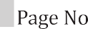
Signature of the Faculty:

